**1 .** You are tasked with designing a simple application for managing a library. The library has different types of items such as books and DVDs. Your task is to create a class hierarchy using inheritance to represent these items in the library. Requirements: Create a base class named LibraryItem with the following attributes:

title (String): the title of the library item , itemID (int): a unique identifier for each library item

 Derive two classes from LibraryItem: 1)Book: represents a book in the library. Include an additional attribute  author (String) for the book's author.

2) DVD: represents a DVD in the library. Include an additional attribute  director (String) for the DVD's director.

 Implement appropriate constructors for each class.

Create a method in the LibraryItem class called displayInfo() that displays the information about the library item (title, itemID). Override the displayInfo() method in the Book and DVD classes to include information specific to each type of item.

Create a test program to demonstrate the functionality of your classes. In the test program, create instances of the Book and DVD classes, and call the displayInfo() method to display their information.  Note: Ensure that the itemID is assigned automatically in a sequential manner for each new library item created.

**Sample output:**

Book Information:

Title: Java language

Item ID: 1

Author: ABC

Type: BOOK

DVD Information:

Title: C language

Item ID:2

Author: Jack sparrow

Type: DVD

DVD Information:

Title: OOP

Item ID:3

Author: Black smith

Type: DVD

**2.**

Write a java program that includes functionalities such as

 1) input string,

 2) Displaying the length,

 3) Finding and displaying the uppercase and lowercase versions,

 4) Checking if the string is a palindrome,

5) Counting the occurrences of a specific character. and 6) string concatenation.

**3.** A Java program that performs various operations on arrays. Your program should include the following functionalities:

Input: Prompt the user to enter the size of an array. Allow the user to input the elements of the array. Display: Display the entered array.

 1) Find and Display: Find and display the sum of all elements in the array.

2) Find and display the average of the elements.

 3) Find and display the maximum and minimum values in the array.

 4) Search: Prompt the user to enter a value to search for in the array. Display whether the value is present in the array and, if yes, display its index.

**4.** BankAccount class is defined with methods for deposit, withdrawal, and getting the balance. The withdraw method throws a custom InsufficientFundsException if the withdrawal amount exceeds the account balance.

The BankApplication class shows the use of this bank account by taking user inputs for account details, deposit, and withdrawal amounts. It includes a try-catch block to handle the custom exception and a finally block to display the current balance regardless of whether an exception occurred or not.

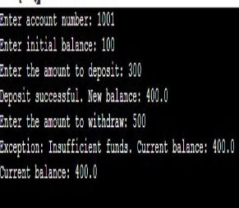

**5.**

Create a arraylist for software companies [Google, Apple, Microsoft, Amazon, Facebook]  and Perform following operations on Arraylist :

1. Add a new software company name in the above arraylist- CapGemini, and display the output.
2. Replace the 3rd company from an array list with a new company name and display the output.
3. Delete the  4th company from the array list and display the arraylist
4. Add sub arraylist in the above arraylist-[Walmart,Cognizant,HSBC] and display the output.
5. Search that given company name is exist in arrayList or not.

6. You are tasked with creating a Java program that counts the number of unique words in a given text using a HashSet.

**Requirements:**

**WordCounter Class:**

* Create a WordCounter class that includes the following:
* A method countUniqueWords(String text) that takes a text as input and returns the count of unique words.
* Use a HashSet to store unique words.
* Consider a word as any sequence of characters separated by whitespace.

**Main Application:**

* Implement a main application that demonstrates the functionality of the WordCounter class.
* Allow the user to input a text string.
* Use the WordCounter class to count and display the number of unique words in the input text.

**Sample Output :**

Enter a text string: This is a simple Java program. Java is powerful and simple.

Number of unique words: 8

**7.**Write a Java program to create a class called Student with private instance variables student_id, student_name, and grades. Provide public getter and setter methods to access and modify the student_id and student_name variables. However, provide a method called addGrade() that allows adding a grade to the grades variable while performing additional validation.

**Sample I/P** Please Enter Your Id:1001,

Please Enter Your Name:Rahul Jadhav,

Please Enter Your Marks: 90 78 87 91 **(Use ArrayList to store the marks)**

**Sample output:** Student ID: 1001

Student Name: Rahul Jadhav

Grades: [90, 78, 87, 91]

**8.** Write a Java program to create a banking system with three classes - Bank, Account, SavingsAccount, and CurrentAccount. The bank should have a list of accounts and methods for adding them. Accounts should be an interface with methods to deposit, withdraw, calculate interest, and view balances. SavingsAccount and CurrentAccount should implement the Account interface and have their own unique methods.

**Case1:**Savings Account:

Initial Deposit: 1000.00

Interest rate: 1.25%

**Case 2:**Current Account:

Initial Deposit: 5000.00

OverdraftLimit: 1000.00

**Case3:**Deposit to  Account:

Now  100 to Savings Account.

Now deposit 500 to Current Account

**Case4:**Withdraw from  Account:

Withdraw 150 from Savings Account.

**Case5:** Account Balance:

Savings A/c and Current A/c.:

Account balance: 950.0

Account balance: 5500.0

**Case6:** Apply Intrest:

After applying interest on Savings A/c for 1 year:

Savings A/c and Current A/c.:

Account balance: 961.875

Account balance: 5500.0

**9.** You are tasked with developing a simple Vehicle Rental System in Java. The system should allow users to rent different types of vehicles, such as cars and bicycles. Implement an class called Vehicle to represent the common attributes and behaviors of all vehicles. Then, create two subclasses, Car and Bicycle, that inherit from the Vehicle class.

**Requirement:**

**Vehicle Class:** Include the following attributes:

* id (unique identifier for each vehicle)
* brand (the brand or make of the vehicle)
* rentalRate (the cost per hour for renting the vehicle)

Include the following methods:

* displayDetails() (display the details of the vehicle)
* calculateRentalCost(int hours) (calculate the total rental cost based on the rental rate and the number of hours)

**Car Class:**

* Extend the Vehicle class. Include an additional attribute: numSeats (the number of seats in the car) Override the displayDetails() method to include car-specific details.
* **Bicycle Class:**
* Extend the Vehicle class. Include an additional attribute: type (the type of bicycle, e.g., mountain bike, road bike)
* Override the displayDetails() method to include bicycle-specific details.
* **Main Application:**
* Implement a main application that demonstrates the functionality of the system.
* Allow users to:
  + Add new cars and bicycles to the system with their details.
  + Display the details of all available vehicles.
  + Rent a vehicle by specifying the vehicle ID and the number of hours.
  + Display the rental details, including the total cost.
  + 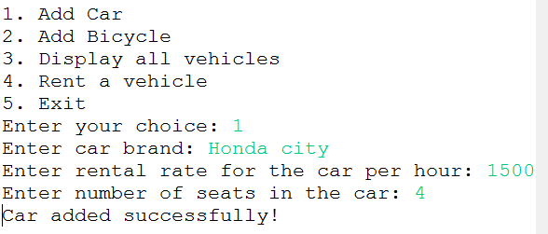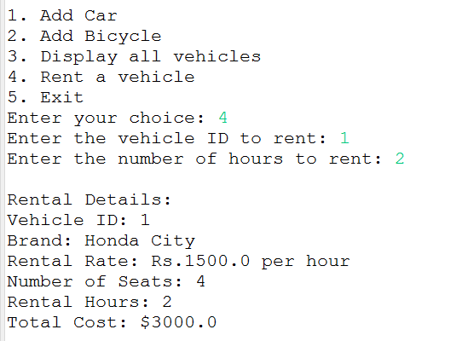

**10.**

**a.** Check that given **number is Armstrong or not.**Eg-153=13+53+33=1+225+27=153

**b.** Write a Java program to check whether two strings are anagram or not? RACE and CARE are anagram strings.

**c.** Take two DOB in string format from user .Compare it and display the messages as “Younger”, ”Elder” or “Same age”.

**11.** a.Write a program to create and traverse (or iterate) ArrayList using for-loop,

iterator, and advance for-loop.

b. check if element(value) exists in ArrayList?

c. add element at particular index of ArrayList?

d. remove element at particular index of ArrayList?

e. sort a given array list.(collections.sort())

f. reverse elements in an array list.

g. compare two array lists.

h. find first and last occurrence of repeated element.

**12. a.** Create arrayList, add the integer elements in arrayList using asList().Remove the duplicate values and return a arrayList containing unique values. Implement the logic inside removeDuplicates() method. Test the functionalities using the main () method of the Tester class. Sample Input and Output---------10, 20, 10, 15,40,15,40 --- 10,20,15,40

b. Given two lists, concatenate the second list in reverse order to the end of the first list and return the concatenated list. Implement the logic inside concatenateLists() method. listOne = Hello 102 200.8 25 listTwo = 150 40.8 welcome A output: Hello 102 200.8 25 A welcome 40.8 150

**13**.a) Implement the method findNumbers accepting two numbers num1 and num2 based on the conditions given below:

Validate that num1 should be less than num2 .If the validations are successful

populate all the 2 digit positive numbers between num1 and num2 into the provided numbers array if sum of the digits of the number is a multiple of 3

number is a multiple of 5 Return the numbers array

Test the functionalities using the main method of the Tester class.

b) **Program to add any two given matrices and print the result.**

**14)** A Company manufactures Vehicles, which could be a Helicopter, a Car, or a Train depending on the customer’s demand. Each Vehicle instance has a method called move, which prints on the console the nature of movement of the vehicle. For example, the Helicopter Flies in Air, the Car Drives on Road and the Train Runs on Track. Write a program that accepts input from the user on the kind of vehicle the user wants to order, and the system should print out nature of movement. Implement all Java coding best practices to implement this program.

**15)** You are required to compute the power of a number by implementing a calculator. Create a class My Calculator which consists of a single method long power (int, int). This method takes two integers n and p, as parameters and finds (n)p. If either or is negative, then the method must throw an exception which says " n or p should not be negative”. Also, if both and are zero, then the method must throw an exception which says "n or p should not be negative”.

16) . Write a Java Program to iterate ArrayList using for-loop, iterator, and advance for-loop. Insert 3 Array List.Input 20 30 40Output:  
  
  
iterator Loop:  
20  
30  
40  
Advanced For Loop:  
20  
30  
40  
For Loop:  
20  
30  
40

17) Write a program to implement following inheritance. Accept data for 5 persons and display the name of employee having salary greater than 5000.  
  
Class Name: Person  
Member variables:  
Name, age  
  
Class Name: Employee  
Member variables:  
Designation, salary

**18)** Create a class Student with attributes roll no, name, age and course. Initialize values through parameterized constructor. If age of student is not in between 15 and 21 then generate user-defined exception "AgeNotWithinRangeException". If name contains numbers or special symbols raise exception "NameNotValidException". Define the two exception classes.

19) Write a Java Program to count the number of words in a string using HashMap. Output:  
Input :Enter String: "This this is is done by Saket Saket";  
{Saket=2, by=1, this=1, This=1, is=2, done=1}

20)

1. Write a Java program to display the pattern like a diamond.  
   Input number of rows (half of the diamond) :7 Expected Output :  
     
   *   
   ***   
   *****   
   *******   
   *********   
   ***********   
   *************   
   ***********   
   *********   
   *******   
   *****   
   ***   
   *

B ) Display the letter L in star pattern.

*

*

*  
* * * *

**21)** We have to calculate the percentage of marks obtained in three subjects (each out of 100) by student A and in four subjects (each out of 100) by student B. Create an abstract class 'Marks' with an abstract method 'getPercentage'. It is inherited by two other classes 'A' and 'B' each having a method with the same name which returns the percentage of the students. The constructor of student A takes the marks in three subjects as its parameters and the marks in four subjects as its parameters for student B. Create an object for eac of the two classes and print the percentage of marks for both the students.

**22)**  1) Java Program to Count Number of Duplicate Words in String

2) How to Check if the String Contains 'e' in umbrella

3) Write a Java program to find the common elements between two arrays of integers.

**23) a) Write a Java program to segregate all 0s on left side and all 1s on right side of a given array of 0s and 1s.**

**b)** Write a Java program to segregate all 0s on left side and all 1s on right side of a given array of 0s and 1s.

24) a) Write a Java Program to find the highest number and lowest number in an array.

1. **Calculate and return the sum of all the even numbers present in the numbers array passed to the method calculateSumOfEvenNumbers. Implement the logic inside calculateSumOfE venNumbers() method.Test the functionalities using the main() method of the Tester class.**

**25) a)** Write a Java program to create a class known as Person with methods called getFirstName() and getLastName(). Create a subclass called Employee that adds a new method named getEmployeeId() and overrides the getLastName() method to include the employee's job title.

b) Write a java program to check that given number is prime or not.

**26)** Write a java program for calculator

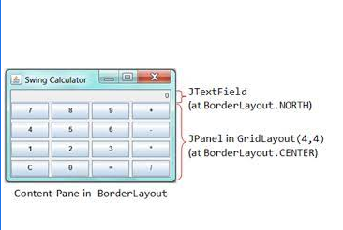

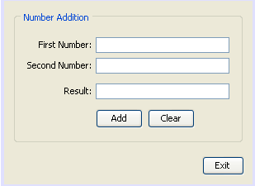**27) Write a java program for display the result .**

**28)** Write a Java method to find all twin prime numbers less than 100.

Twin primes are primes whose difference is 2 and only one composite no between them.

Expected Output:

(3, 5)

(5, 7)

(11, 13)

(17, 19)

(29, 31)

(41, 43)

(59, 61)

(71, 73)

**29) a)**Write a Java method that checks whether all the characters in a given string are vowels (a, e,i,o,u) or not. Return true if each character in the string is a vowel, otherwise return false.

Expected Output:

Input a string: AIEEE

Check if all the characters of the said string are vowels or not!

True.

**b)**Design a class ‘Complex ‘with data members for real and imaginary part. Provide default and Parameterized constructors. Write a program to perform arithmetic operations of two complex numbers.

**30) a)** WAJP that reads on file name from the user, then displays information about whether the file exists, whether the file is readable, whether the file is writable, the type of file and the length of the file in bytes.

**b)** Write a program to give the example for method overriding concepts.

31) .Create class box and box3d. box3d is extended class of box. The above two classes going to pull fill following requirement

* Include constructor.
* set value of length, breadth, height
* Find out area and volume.

32) a) [Java Program to Iterate through Elements of HashMap](https://www.geeksforgeeks.org/iterate-map-java/)

B) Write a Java program to perform a runnable interface, take two threads t1 and t2 and fetch the names of the thread using getName() method.

33) a).WAJP that reads on file name from the user, then displays information about whether the file exists, whether the file is readable, whether the file is writable, the type of file and the length of the file in bytes.

b) Write a program to create a class named shape. In this class we have three sub classes circle, triangle and square each class has two member function named draw () and erase (). Create these using polymorphism concepts.

34)a)Create an outer class with a function display, again create another class inside the outer class named inner with a function called display and call the two functions in the main class.

b)Write a program to give the example for method overriding concepts.

35)  Write a Java program for following

 a) TO reads a list of numbers from a file and throws an exception if any of the numbers are positive.

b)      Reads a list of integers from the user and throws an exception if any numbers are duplicates.

36)

Write a Java program for following

            A) Write a method that returns a new array that contains the elements of the input array in the reverse        order   ( Example : Input: [1,4,7,3,6]   Output: [6,3,7,4,1] )

        B) Write a Java program to convert a hash set to an array.

37)  Write a Java program

       a) To create a bank account with concurrent deposits and withdrawals using threads.

        b) To calculate the sum of all prime numbers up to a given limit using multiple threads.

38)   a)  Write a Java program to create an abstract class Bird with abstract methods fly() and                makeSound(). Create subclasses Eagle and Hawk that extend the Bird class and implement the respective methods to describe how each bird flies and makes a sound.

      b) Write a Java program to create a base class Vehicle with methods startEngine() and stopEngine(). Create two subclasses Car and Motorcycle. Override the startEngine() and stopEngine() methods in each subclass to start and stop the engines differently.

39) How to remove specific characters in the String? To remove specific characters in the String .

For example, If the *original string is* "Alive is awesome"   and the *user inputs string* to remove "alwsr"  then it should print  "ive i eome" as output .

If the *original string is* "Learning never stops"   and the *user inputs string* to remove "estp"  then the it should print   "Larning nvr o" as output **.**

**40) Write a Java program to get the file size in bytes, KB, MB.**

**Sample O/P: 151000 bytes**

**1474  kb**

**1 mb**

**2. Write a java program to calculate the total number of Words and Characheters in Text Area of Swing GUI**

41)   Write a Java program to create a method that takes a string as input and throws an NoVowelsFound exception if the string does not contain vowels. **Sample I/P: Case-1 Please Enter the string: "This is my Country"  Sample Ouput: String contains vowels. Case-2 Please Enter the string: "Typy gyps fly"**

**Sample Output :Error: String does not contain any vowels**

42) Write a Java program to create GUI using swing for calculating the area traingle. 1. Add two text fields for I/Ps and One text Field for Output. Add one button named :"Calculate Area". Name the Text Fields as Height, Base, and Area of Triangle.

43) Write a Java program to display the following character rhombus structure.

Test Data

Input the number: 3

Expected Output :

              A

           ABA

         ABCBA

           ABA

             A